Using the 960 Grid System as a Design Framework -->
1- Streamlines the design process by defining exact measurements
2- There are two major CSS Frameworks at the moment: Blueprint and 960. Both
3- 960 gs is based around putting all of your site's elements in a 960px wide container, and dividing that container into 12, 16, or 24 equally sized columns

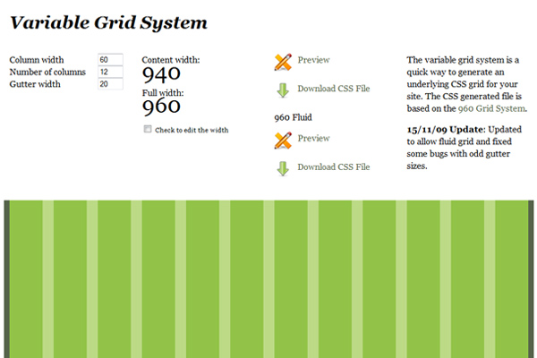

Why 960px?
1- Because 960px is a width that is suited for the wide number of platforms on which we browse the web.
2-It allows for a 1024px wide monitor to show the site accurately and without horizontal scrolling.
3- There is always a 10px margin placed at the right and left of the main content column
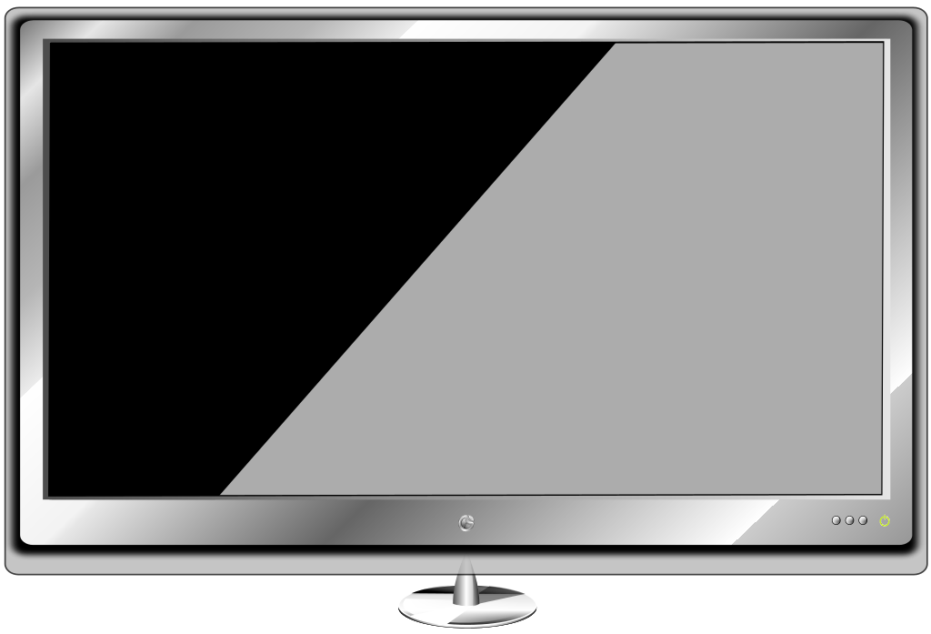

Piont ->
You still have to design everything on the site (of course!), but by keeping your design in line with the guides, it'll make the development side of things much easier.
1-all numbers in the 960GS are whole numbers based on the golden ratio - there are no decimal points or funky spacing issues
How to download grid 960 ->
1- download site - https://960.gs/
2- after download you can unzip the folder and you will many get folder like
1- sketch_sheets - folder contains a PDF of the various grid sizes
2-template - folder contains templates for almost every graphics program
3- code – css - ( 960.css , text.css ,reset.css)
how to use -
1- reset.css - reset file that accounts for browser quirks
2- text.css - he built-in typography stylesheet
3- 960.css – all gird columns combinations

960 Grid Tutorial – Understanding Alpha and Omega classes -->
Number three in my short series explaining a little bit about how the 960 Grid system works in osCommerce…Alpha and Omega Classes
The Alpha and Omega class is used to align the first and last “child” divs of a parent div to the outermost margins of the page…what is a child div? Have a look at this code;

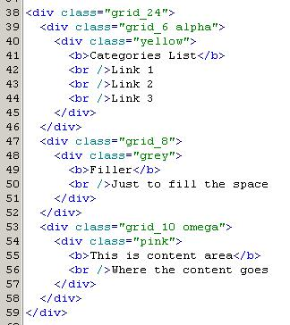
Which produces this layout;

The next image shows the same code with a bit of explanation;
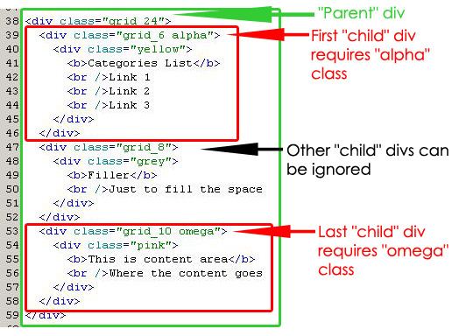
If I remove the alpha and omega class, the display reacts badly;
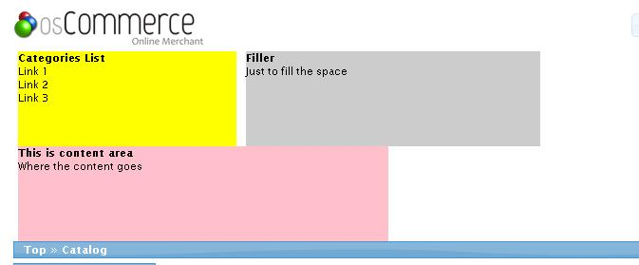
Why is this? It is because the “alpha” and “omega” classes “remove” the gutter left and right (not exactly but it’s the easiest way to explain it). In the image below I have shown this in red to illustrate the area that adding the “alpha” class changes;
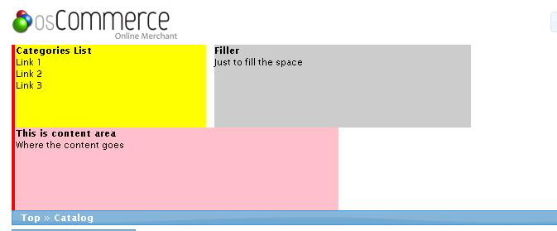
Adding the “alpha” class back in;
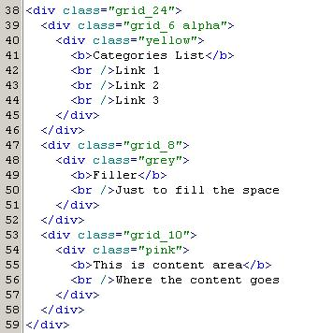
shifts the yellow div back over to it’s rightful place;
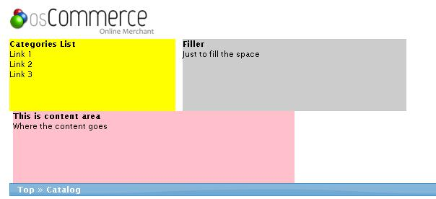
Yet the pink child div is still in the wrong place. This is because we need to add the “omega” class to it. Once done, everything lines up perfectly;
Summary
The “alpha” class is used on the FIRST “child” div. It shifts the div to the left to make it line up with your design.
The “omega” class is used on the LAST “child” div. It shifts the div to the right to make it line up with your design.
You should use “alpha” and “omega” classes when the div’s you use them on are also grid_* divs, and are inside a parent grid_* div.

